Project Title: Library Book Inventory Management System

Student Name: Sarulatha P
Register Number: C4S38004
Department: B.Sc Artificial Intelligence
Course: Artificial Intelligence (AI)
Academic Year: 2026 – 2027

DBMS Practical – Book and Publisher Module

1. Create Database
CREATE DATABASE LibraryDB;
USE LibraryDB;

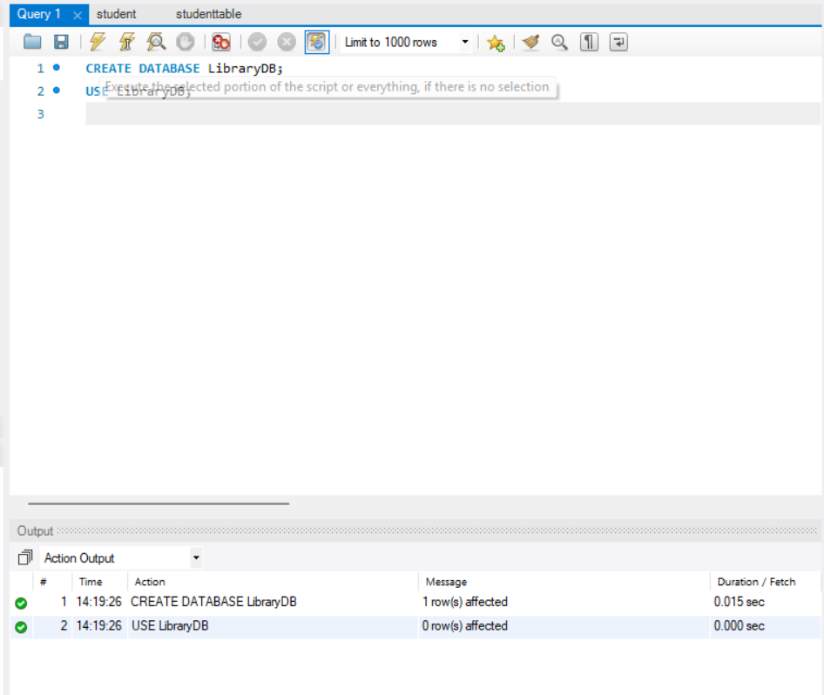

2. Create Publisher Table
CREATE TABLE Publisher (
PublisherID INT PRIMARY KEY,
PublisherName VARCHAR(60),
City VARCHAR(40)
);

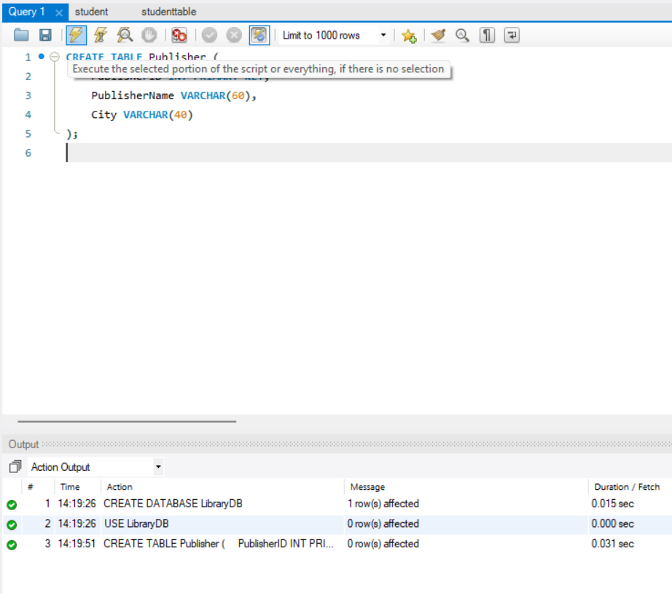

3. Create Book Table
CREATE TABLE Book (
BookID INT PRIMARY KEY,
BookTitle VARCHAR(80),
PublisherID INT,
Price INT,
CopiesAvailable INT,
FOREIGN KEY (PublisherID)
REFERENCES Publisher(PublisherID)
);

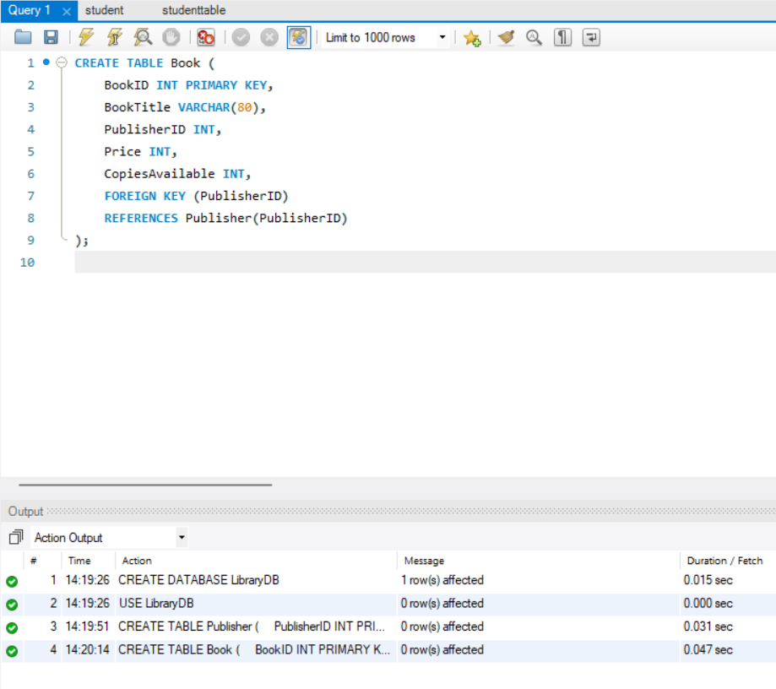

4. Insert Publisher Details
INSERT INTO Publisher VALUES
(1, 'Pearson', 'Chennai'),
(2, 'McGraw Hill', 'Bangalore'),
(3, 'Oxford Press', 'Delhi');
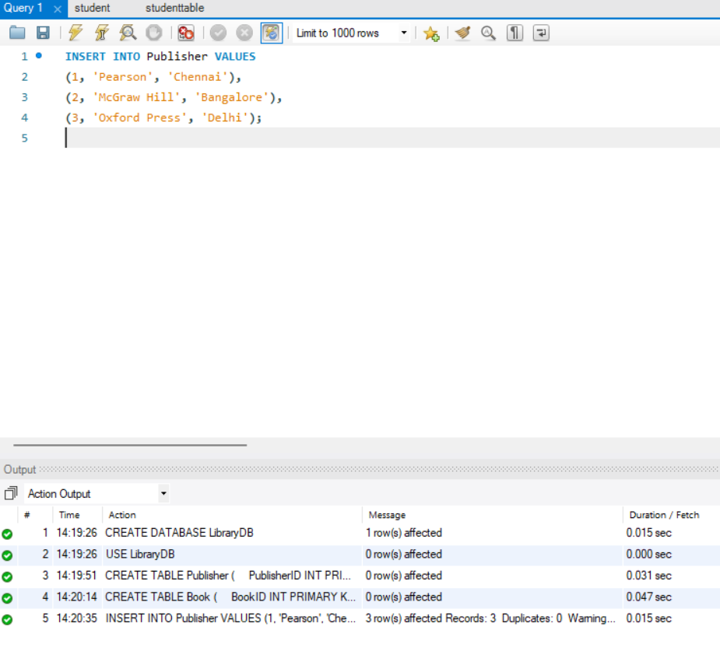

5. Insert Book Details
INSERT INTO Book VALUES
(201, 'Database Systems', 1, 750, 25),
(202, 'Java Programming', 2, 650, 18),
(203, 'Python Basics', 3, 550, 30),
(204, 'Artificial Intelligence', 1, 900, 12);
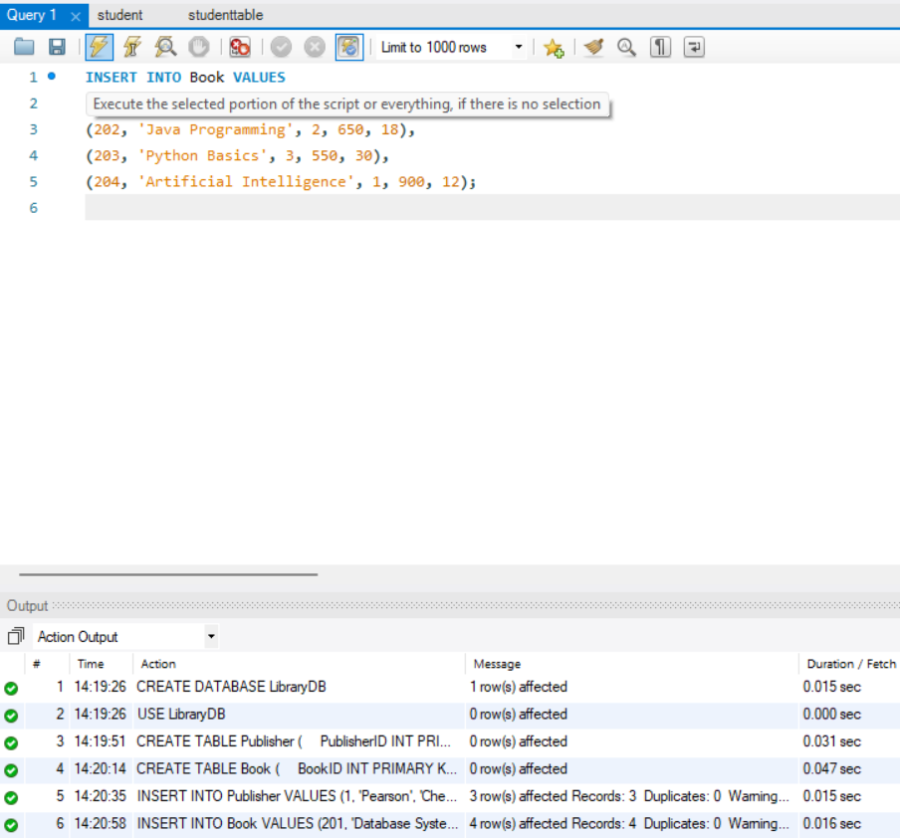

6. Display Book Records
SELECT * FROM Book;
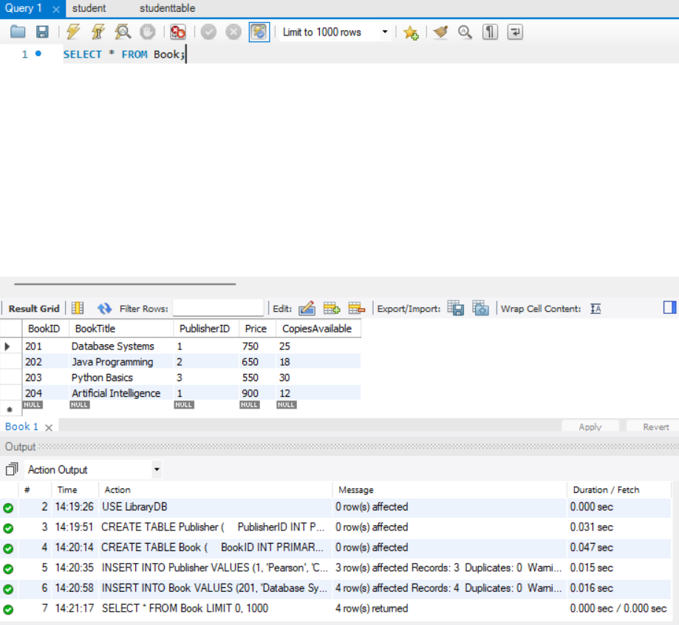

7. Update Book Price
UPDATE Book
SET Price = 800
WHERE BookID = 201;
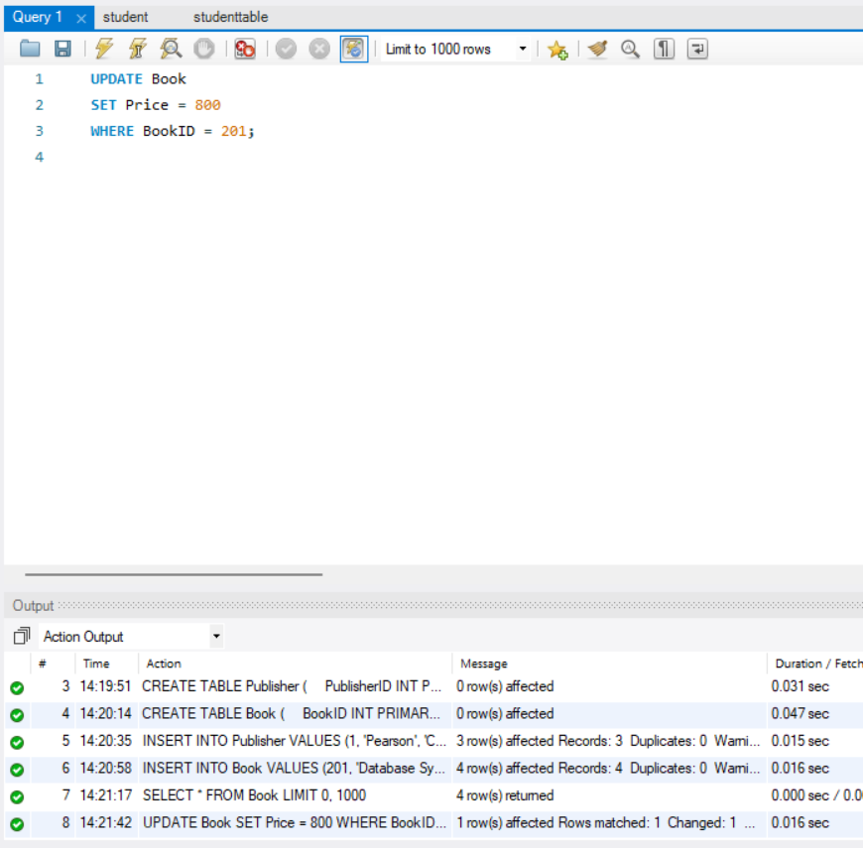

8. Publisher-wise Book Report
SELECT Publisher.PublisherName,
Book.BookTitle,
Book.Price
FROM Publisher
JOIN Book
ON Publisher.PublisherID = Book.PublisherID;
